**Capstone Project Phase A  
  
  
  
improving the accuracy and specificitv of weather forecasts using Infrared satellite images  
  
  
  
25-2-D-33  
  
  
Students:   
  
Mohamad Khateeb Joorj Ishak  
  
  
 Lecturer:   
  
Zakharia Frenkel  
  
  
  
  
  
  
  
  
  
📚 Table of Contents – Infrared-based Urban Temperature Prediction Project**

1. **Introduction**
2. **Literature Review**
3. **Urban Microclimate and the UHI Effect**
4. **Remote Sensing and Infrared****Thermography**
5. **Machine Learning for Land Surface****Analysis**
6. **Land Surface Temperature (LST)****Estimation Methods**
7. **Object-Based Area Measurement in****Satellite Imagery**
8. **General related information**
9. **What is Infrared?**
10. **Infrared resources**
11. **How to recognize Infrared radiation?**
12. **Existing Modern Solutions for Infrared-Based****Weather Forecasting**
    1. **Geostationary Weather Satellites, (e.g., GOES-R****series, Himawari-8, Meteosat).**
    2. **Polar-Orbiting Weather Satellites, (e.g., NOAA-20, Suomi NPP, MetOp).**
    3. **Atmospheric Infrared Sounders, (e.g., AIRS, IASI, CrIS).**
    4. **Infrared-Based Numerical Weather Prediction (NWP) Input.**
    5. **AI-Driven IR Forecast Models, (e.g., Google’s GraphCast, DeepMind’s Nowcasting AI).**
    6. **Ground-Based IR Sensors & Radiometers.**

### **General Improvements That Can Enhance All Infrared-Based Weather Forecasting Systems.**

1. **System Architecture and Flow**
2. **Input Data Sources (RGB, TIR, Metadata)**
3. **SegFormer-Based Semantic Segmentation**
4. **Thermal Image Calibration and Conversion to****LST**
5. **Proposed Enhancements Over Existing Work**
6. **Accurate Area Measurement per Object**
7. **Mapping Infrared Values to Segmented Objects**
8. **Fusion of Segmentation and Temperature Layers**
9. **Methodology**
10. **Data Preprocessing**
11. **Segmentation Using SegFormer**
12. **Land Surface Temperature Computation (Mono-Window)**
13. **Object-Level Temperature Mapping**
14. **Dataset Construction for Correlation**
15. **Area and Temperature Correlation Analysis**
16. **Expected Results**
17. **Spatial Distribution of Urban Heat**
18. **Object-Level Temperature Profiles**
19. **Actionable Insights for Urban Planning**
20. **Evaluation and Validation**
21. **Segmentation Accuracy Metrics (IoU, Dice)**
22. **LST Accuracy Against Ground Stations**
23. **Correlation Validation and Visualization**
24. **Tools and Resources**
25. **Google Earth Engine**
26. **Python + SegFormer + Rasterio + NumPy**
27. **Datasets Used (Landsat, Sentinel, DeepGlobe,****WHU)**
28. **Conclusion and Future Work**

**Abstract:**

Urbanization is accelerating across the globe, reshaping landscapes and amplifying the effects of climate change—particularly through the intensification of the Urban Heat Island (UHI) phenomenon. This effect, where urban regions exhibit significantly higher temperatures than their rural surroundings, poses increasing risks to public health, energy sustainability, and urban infrastructure. Traditional weather forecasting models, though useful on a macro scale, lack the spatial resolution necessary to assess localized variations in temperature across different city regions and land types.

This project introduces a comprehensive methodology for analyzing urban microclimates at a high spatial and semantic resolution by integrating semantic segmentation of satellite imagery with thermal infrared (TIR) temperature data. Leveraging the power of **SegFormer**, a cutting-edge transformer-based deep learning model for semantic segmentation, we classify urban features such as buildings, roads, green areas, water bodies, and soil. Each pixel in the satellite imagery is assigned a land cover category, and its physical area is calculated using satellite metadata (resolution and geographic information).

Simultaneously, we process thermal bands from satellites such as **Landsat 8** to extract surface temperature values in degrees Celsius. These values are then spatially aligned with the segmented land cover map to compute average temperature values per object. The result is a rich dataset that maps both the geometry and thermal behavior of urban features over time.

Through case studies across cities like Dublin, Gilbert, and Katy (Texas), as well as suburban developments such as The Villages (Florida), the project identifies how urban expansion, vegetation loss, and material usage contribute to microclimate evolution. Visualizations generated for multiple years show how urban growth affects surface temperature patterns. These insights offer actionable knowledge for urban planners, environmental scientists, and policymakers seeking to design cities that are both sustainable and resilient to heat.

# **Introduction:**

In the face of accelerating global urbanization and rising climate instability, understanding the dynamics of urban heat has never been more critical. Cities today are not just centers of population and economic activity—they are also hotspots of thermal stress. The Urban Heat Island (UHI) effect, where urbanized regions exhibit significantly higher temperatures than their rural surroundings due to human activity and land surface modifications, is becoming a dominant environmental concern. This phenomenon results from the replacement of natural vegetation with impervious surfaces such as asphalt, concrete, and metal, which absorb and re-radiate heat more intensely than soil or vegetation.

These elevated urban temperatures exacerbate health risks, increase cooling energy demands, and reduce livability—especially in vulnerable communities. Yet, despite its significance, the granular analysis of UHI at the object or neighborhood scale remains a technical challenge. Existing meteorological models often operate at low spatial resolutions (kilometers per pixel), failing to capture micro-level variations within a city, such as temperature differences between tree-lined streets and concrete parking lots.

To overcome these limitations, our project proposes an integrative approach based on remote sensing, machine learning, and geospatial analysis. The core innovation lies in the fusion of semantic segmentation and thermal imaging:

* Semantic Segmentation with SegFormer: Using a transformer-based architecture, we classify satellite imagery at the pixel level into detailed categories: rooftops, roads, vegetation, water bodies, and more. This model outperforms traditional CNNs in handling diverse urban geometries and scales.
* Thermal Infrared Analysis: Surface temperature data is derived from thermal infrared bands of satellites like Landsat 8 (Band 10), and calibrated to Celsius using established radiometric formulas.
* Object-Level Fusion: Each classified object is paired with its corresponding thermal data to produce object-level temperature metrics—a novel method that quantifies not just “where it’s hot,” but “what is hot and why.”

To validate our framework, we conducted spatial-temporal analyses on a diverse set of urban and suburban areas:

* Dublin (2009 vs 2018): A densely built European city with expanding commercial zones.
* Gilbert, Arizona (2013 vs 2019): A rapidly developing suburban area in a desert climate.
* Katy, Texas (2012 vs 2018): A mid-sized city with increasing residential sprawl.
* The Villages, Florida (2007 vs 2017): A retirement-focused suburban development with significant land transformation.

Each location provided insight into how land use evolution—e.g., reduction of vegetation, expansion of concrete surfaces—relates directly to heat accumulation.

By mapping these changes visually and numerically, our system enables urban planners, architects, environmental agencies, and municipal leaders to identify areas most at risk from thermal stress. This can guide strategies such as targeted tree planting, adoption of reflective materials, or zoning reforms that mitigate UHI impact.

Our long-term goal is to support the development of smart, climate-adaptive urban systems that enhance urban quality of life while responding to the realities of climate change.

1. **Literature Review:**

## **Urban Microclimate and the Urban Heat Island (UHI) Effect:**

Urban microclimates refer to localized climate conditions within built environments, which often differ significantly from surrounding rural areas. One major factor is the Urban Heat Island (UHI) effect, where urban zones exhibit higher surface and air temperatures due to dense infrastructure, heat-absorbing materials like asphalt and concrete, and a lack of vegetation.

Studies have shown that temperature differences between urban and rural areas can exceed 5°C, particularly during nighttime. These effects are further amplified by global climate change, making UHI a critical concern for urban resilience and sustainability.

1. **Remote Sensing and Thermal Infrared (TIR) Imagery:**

Remote sensing technologies allow the estimation of Land Surface Temperature (LST) through satellite-acquired thermal infrared (TIR) imagery. Satellites such as Landsat 8/9 and Sentinel-3 provide thermal bands capable of measuring emitted radiation from the Earth’s surface.

With appropriate calibration and algorithms like the Mono-Window or Split-Window methods, raw thermal data can be converted into precise surface temperature values. LST has become a central parameter in identifying heat islands and studying spatial heat distribution.

1. **Semantic Segmentation Using Deep Learning:**

Recent advances in deep learning have significantly improved our ability to analyze high-resolution satellite imagery. In particular, semantic segmentation models label each pixel in an image with a specific land cover category (e.g., roof, road, vegetation).

The SegFormer model, based on transformer architectures, has shown state-of-the-art performance in segmentation tasks. It enables fine-grained classification of urban features—an essential step before correlating objects with thermal data.

1. **Object-Based Area Measurement:**

Once segmentation is complete, the true physical area of each object can be calculated using pixel resolution metadata. For example, a satellite image with 10 meters per pixel allows each pixel to represent 100 square meters. This enables precise quantification of building footprints, green spaces, and road surfaces—not just as a percentage of the image but in real-world units (m²).

1. **Fusion of Segmentation and Thermal Layers:**

Combining semantic segmentation with LST data leads to powerful spatial analysis. By mapping average temperature values to individual segmented objects, researchers can determine which urban elements contribute most to localized heating.

Recent studies suggest this fusion has strong potential, but there is still a gap: few methods offer object-level pairing of area and temperature data. This project aims to bridge that gap by introducing a system that links urban geometry with thermal behavior per object.

1. **General related information:**
   1. **What is Infrared?**  
      Infrared (IR) is a type of electromagnetic radiation with wavelengths longer than visible light but shorter than microwaves. It typically spans wavelengths from about 0.75 micrometers (µm) to 1000 µm (or 1 millimeter). Infrared is invisible to the human eye, but we can feel it as heat.
   2. **Infrared resources**  
      Infrared (IR) radiation is emitted by **any object with a temperature above absolute zero (−273.15°C or 0 K)**. This means **all natural and artificial objects** can be sources of infrared, depending on their temperature and properties.

Here’s a breakdown of **main sources of infrared radiation**:

**Natural sources of Infrared:   
The earth:**

* The Earth’s surface absorbs sunlight and re-emits energy as **infrared radiation**, mostly in the **8–15 µm range**.
* Plays a key role in the **greenhouse effect**.

**The sun:**

* Emits energy across the entire electromagnetic spectrum.
* Roughly **50% of solar energy** that reaches Earth is in the **infrared range**.
* Dominant in the **near-infrared (0.75–2.5 µm)**.

**The atmosphere:**

* **Water vapor**, **CO₂**, and other gases **absorb and re-emit** IR, especially in the mid and longwave IR bands.
* Clouds emit IR radiation depending on their temperature and altitude.

**Celestial bodies:**

* Stars, planets, dust clouds, and galaxies emit infrared.
* Used in **astronomy** to study cold, dark, or distant objects that are invisible in visible light.

**Artificial (Man-Made) sources of Infrared:**

**Incandescent Bulbs:**

* Emit IR as a byproduct of heat—only ~10% of energy goes to visible light; the rest is IR.

Electric Heaters & Stoves:

* Produce strong IR radiation as they heat up to hundreds of degrees Celsius.

Infrared LEDs & Lasers:

* Emit precise IR wavelengths used in **remote controls**, **IR cameras**, **sensors**, and **communication systems**.

Satellites & Sensors:

* Satellites with **active IR instruments** can emit IR pulses and measure their reflection (e.g., for terrain mapping or moisture detection).

* 1. **How to recognize Infrared radiation?**

Infrared (IR) waves are **invisible** to our eyes, but we can **recognize or detect** them using specific **tools, sensors, or indirect effects**.

**Here are the main ways to recognize infrared waves:**

**By Sensing Heat:**

* **IR = Heat radiation**. Anything warm emits infrared.
* You **feel** infrared as **warmth** on your skin, even if you can’t see it.
  + Example: Standing near a heater or campfire—you feel the heat (IR), not the light.

**Using Infrared Cameras (Thermal Imaging):**

* Converts infrared radiation into visible images.
* Warmer objects appear **brighter** (white, yellow, red), cooler objects **darker** (blue, black).
* Used in:
  + Building inspections (heat leaks)
  + Military & security (night vision)
  + Medical scans (inflammation detection)
  + Wildlife observation

**Using Phone or Digital Camera (Simple Test):**

* Point a **TV remote control** at your phone camera and press a button.
* You’ll see a **blinking light** on your screen – that’s **near-infrared** from the remote’s LED (invisible to the eye, but detected by the camera sensor).

**Infrared Sensors and Thermometers:**

* Devices like **non-contact thermometers** use IR to measure surface temperature.
* Infrared **motion sensors** detect body heat to trigger lights or alarms.

**Satellite Sensors:**

* Weather satellites use IR to detect **cloud temperature**, **storm intensity**, and **ocean heat patterns**.
* Astronomical satellites like **Spitzer** observe galaxies and stars in IR.

**Special Lab Equipment:**

* **Spectrometers** detect specific IR wavelengths reflected or absorbed by materials.
* **IR spectroscopy** is used in chemistry to analyze molecular structure.

1. **Existing Modern Solutions for Infrared-Based Weather Forecasting:**

There are several modern solutions that detect infrared (IR) radiation and analyze weather using it. These systems are largely based on satellites, sensors, and advanced models. Below is a comprehensive summary of major current solutions, how they work, and what challenges they face:

* 1. **Geostationary Weather Satellites, (e.g., GOES-R series, Himawari-8, Meteosat):**

**How it works:**

* Orbit the Earth at a fixed point over the equator.
* Constantly scan large regions using IR and visible imagers.
* Detect cloud temperature, cloud height, and storm development.

**Challenges:**

* Resolution is limited (about 0.5–2 km).
* Difficult to capture vertical structure of clouds.
* IR can’t see through thick clouds or measure lower atmosphere precisely.
  1. **Polar-Orbiting Weather Satellites, (e.g., NOAA-20, Suomi NPP, MetOp):**

**How it works:**

* Orbit from pole to pole, scanning different parts of the Earth with each pass.
* Provide high-resolution IR data over every part of the planet twice daily.
* Feed into global numerical weather models.

**Challenges:**

* Less frequent coverage for any single location.
* Data must be rapidly processed to be useful in forecasting.
  1. **Atmospheric Infrared Sounders, (e.g., AIRS, IASI, CrIS):**

**How it works:**

* Instruments on polar satellites that measure IR at many wavelengths.
* Estimate vertical profiles of temperature, humidity, and trace gases.
* Critical for initializing weather prediction models.

**Challenges:**

* Data requires complex radiative transfer models to interpret.
* Accuracy drops in cloudy regions.
* Sensitive to sensor calibration and atmospheric interference.
  1. **Infrared-Based Numerical Weather Prediction (NWP) Input:**

**How it works:**

* IR data from satellites is fed into global models (e.g., ECMWF, GFS).
* Used in data assimilation to correct and update forecasts.
* Helps improve predictions for storms, rainfall, and temperature.

**Challenges:**

* Errors in satellite measurements or timing can corrupt model output.
* Assimilation algorithms must account for cloud interference and surface reflection.
* Requires large computing power.
  1. **AI-Driven IR Forecast Models, (e.g., Google’s GraphCast, DeepMind’s** **Nowcasting AI):**

**How it works:**

* Use machine learning to analyze satellite IR imagery and generate predictions.
* Learn atmospheric patterns directly from historical IR data.

**Challenges:**

* Data-hungry: requires massive training datasets.
* Lacks explainability—“black box” models.
* Still experimental for long-range predictions.
  1. **Ground-Based IR Sensors & Radiometers:**

**How it works:**

* Used at weather stations or research facilities.
* Measure upward and downward IR radiation for local temperature, cloud cover, and radiative flux.

**Challenges:**

* Only provide point measurements.
* Affected by local terrain and pollution.
* Require clear line of sight to sky for cloud measurement.

### **General Improvements That Can Enhance All Infrared-Based Weather Forecasting Systems:**

* **Multi-source Data Fusion** – Combining infrared data with radar, LiDAR, and optical sensors to produce a more comprehensive and accurate atmospheric profile.
* **AI for Noise Reduction and Interpretation of IR Data** – Using artificial intelligence to clean infrared imagery and convert thermal images into meaningful physical insights.
* **Advanced and More Accurate Sensors** – Implementing technologies like **quantum detectors** and **hyperspectral infrared sensors** to achieve higher precision and sensitivity.
* **Increased Measurement Coverage** – Deploying small satellites (CubeSats), stratospheric balloons, and drones to expand spatial and temporal data collection.
* **Enhanced Learning from Historical Models** – Leveraging machine learning on historical weather and IR data to better understand and predict extreme weather phenomena.

# **System Architecture and Flow:**

# **Input Data Sources (RGB, TIR, Metadata):**

The system begins by ingesting high-resolution satellite imagery from two main sources:

* RGB imagery from Sentinel-2 or equivalent optical satellites, used for semantic segmentation of land cover types.
* Thermal Infrared (TIR) imagery, typically from Landsat 8/9, used for estimating land surface temperature (LST).
* Metadata, such as pixel resolution and radiometric calibration coefficients, is also extracted to enable accurate area calculations and temperature conversion.

These datasets must be co-registered to ensure pixel-level alignment between visual and thermal layers.

1. **SegFormer-Based Semantic Segmentation:**

RGB imagery is processed using the SegFormer model, a transformer-based architecture for semantic segmentation. This model labels each pixel in the image with one of several land cover classes (e.g., buildings, vegetation, roads, water bodies). The output is a segmentation map with labeled urban features.

This segmentation serves as the structural basis for analyzing thermal behavior by isolating specific object types within the urban landscape.

1. **Thermal Image Calibration and Conversion to LST:**

Thermal infrared bands (such as Landsat Band 10) are first converted from raw digital numbers (DN) to radiance, and then to brightness temperature using published calibration formulas.

An additional conversion step is applied to estimate Land Surface Temperature (LST) in degrees Celsius, accounting for surface emissivity and atmospheric effects. One common approach is the Mono-Window algorithm, which is suitable for Landsat data.

The resulting LST image is spatially matched with the segmentation map to enable pixel-level mapping of temperature to individual segmented objects.

# **Proposed Enhancements Over Existing Work:**

## **Accurate Area Measurement per Object:**

While prior studies have addressed segmentation or temperature analysis independently, few have implemented precise quantitative area measurement per object. In this project, each segmented object’s area is computed by counting its pixel coverage and multiplying by the spatial resolution squared (e.g., 10×10 meters = 100 m² per pixel).

This capability enables true physical measurement rather than relative percentages within an image, offering deeper insight into the actual spatial impact of urban structures on localized heat.

## **Mapping Infrared Values to Segmented Objects:**

A novel aspect of this project is the mapping of thermal infrared values (LST) to individually segmented objects. For instance, if a rooftop is identified via segmentation, the system calculates the average surface temperature of all thermal pixels within its bounds.

This object-level mapping goes beyond regional heat analysis and provides a fine-grained understanding of how specific urban elements contribute to thermal variation.

## **Fusion of Segmentation and Temperature Layers:**

The core innovation lies in the spatial fusion of semantic segmentation maps with thermal imagery. By aligning these layers, the system builds a temperature profile for each object, accounting for its physical size, shape, and material type.

Unlike general UHI studies that focus on broad zones, this project enables object-level thermal modeling—empowering urban planners with actionable insights such as where to add shading, greenery, or reflective materials.

# **Methodology:**

## **Data Preprocessing:**

The workflow begins by downloading and aligning two core datasets:

RGB imagery (from Sentinel-2 or similar)

Thermal infrared imagery (TIR) (from Landsat 8/9)

These images are preprocessed to ensure spatial alignment (co-registration), cropping to regions of interest (ROIs), and standardizing resolution. Metadata such as pixel size and radiometric calibration coefficients are also extracted for later use.

## **Segmentation Using SegFormer:**

The preprocessed RGB image is input into a pre-trained SegFormer model. The model performs semantic segmentation, labeling each pixel with a land cover class (e.g., roof, road, vegetation, water).  
The output is a segmentation map with indexed labels per pixel, which is used for object identification and area computation in later steps.

## **Land Surface Temperature Computation (Mono-Window):**

Thermal bands (e.g., Band 10 in Landsat 8) are used to calculate Land Surface Temperature (LST). The Mono-Window algorithm is applied, which converts raw thermal values into surface temperatures in Celsius using radiometric equations, emissivity estimates, and atmospheric parameters.

The result is a temperature map matching the same spatial extent and resolution as the segmentation map.

## **Object-Level Temperature Mapping:**

Each segmented object (e.g., a specific rooftop or green area) is spatially intersected with the LST map. All pixels within the object’s mask are averaged to calculate the mean temperature of the object.

This step links geometric data (shape, area) to environmental behavior (temperature).

## **Dataset Construction for Correlation:**

For each object, a record is generated containing:

Object type (e.g., building, vegetation)

Physical area (m²)

Mean LST (°C)

These records are combined into a structured dataset (e.g., CSV or DataFrame), ready for statistical analysis.

## **Area and Temperature Correlation Analysis:**

The final stage involves analyzing the correlation between object properties (such as area and type) and their average temperatures. Scatter plots, correlation coefficients, and regression models are used to explore:

Which object types retain more heat?

Does area influence heat retention?

What materials or structures contribute most to local heating?

These insights help inform urban planning and mitigation strategies.

### **Expected Results:**

This section outlines the anticipated outcomes from the project, based on data analysis and modeling:

* 1. **Spatial Distribution of Urban Heat:**  
     Analyzing the geographical spread of urban heat zones using remote sensing data.
  2. **Object-Level Temperature Profiles:**  
     Detecting and profiling temperatures at the level of individual urban objects (e.g., buildings, roads).
  3. **Actionable Insights for Urban Planning:**  
     Deriving recommendations from the thermal analysis to support sustainable urban design and heat mitigation strategies.

# **Evaluation and Validation:**

This section details the methods used to evaluate the accuracy and reliability of the system:

* 1. **Segmentation Evaluation:**  
     Assessing the quality of segmented thermal zones using deep learning models.
  2. **Accuracy Metrics (IoU, Dice):**  
     Using Intersection over Union (IoU) and Dice coefficient to quantify the precision of object detection and classification.
  3. **LST Accuracy Against Ground Stations:**  
     Validating Land Surface Temperature (LST) readings by comparing them with data from real-world ground stations.
  4. **Correlation Validation and Visualization:**  
     Statistical validation and graphical interpretation of the relationship between different environmental variables.

# **Tools and Resources:**

This section lists the key tools, frameworks, and datasets used in the project:

* 1. **Google Earth Engine:**  
     For geospatial data processing and visualization of satellite images.
  2. **Python + SegFormer:**  
     Used for thermal image segmentation and analysis using transformer-based neural networks.
  3. **Rasterio + NumPy:**  
     Libraries for reading, manipulating, and analyzing raster datasets and numerical data.
  4. **Datasets Used:**
* **Landsat** (thermal infrared data)
* **Sentinel** (multi-spectral urban imagery)
* **DeepGlobe** (urban object classification)
* **WHU** (building dataset for object-level segmentation)

### **Conclusion and Future Work:**

**Algorithm Steps:**

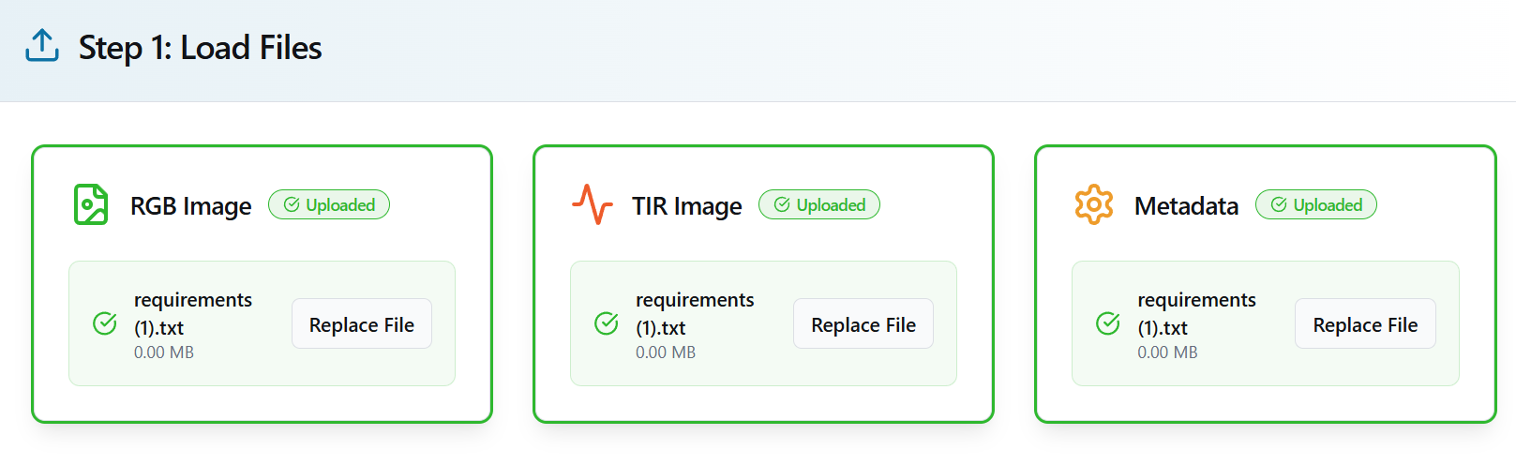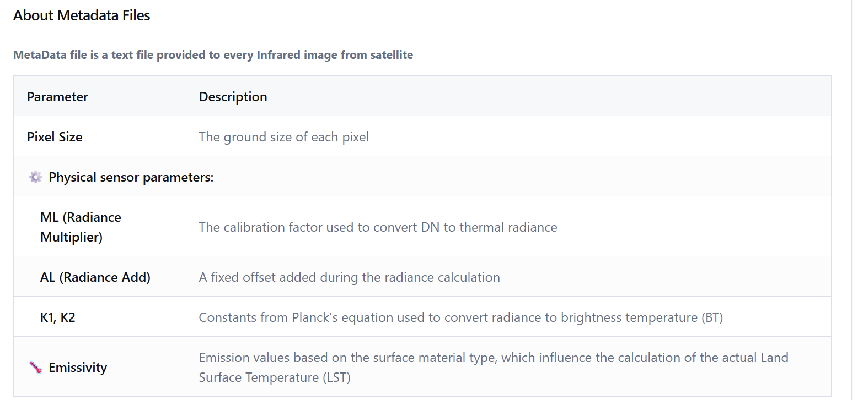

**Step 1: Acquire and Align Satellite Dat**

Action:

Collect satellite images: RGB (e.g., Sentinel-2) and Thermal Infrared (e.g., Landsat 8 Band 10). Align them spatially.

Explanation:

The segmentation model (SegFormer) uses RGB images, while Land Surface Temperature (LST) is calculated from the thermal image. It’s crucial that both images are georeferenced and co-registered so that each pixel in the RGB image matches the corresponding thermal pixel.

Output:

Co-registered RGB and TIR images ready for parallel processing

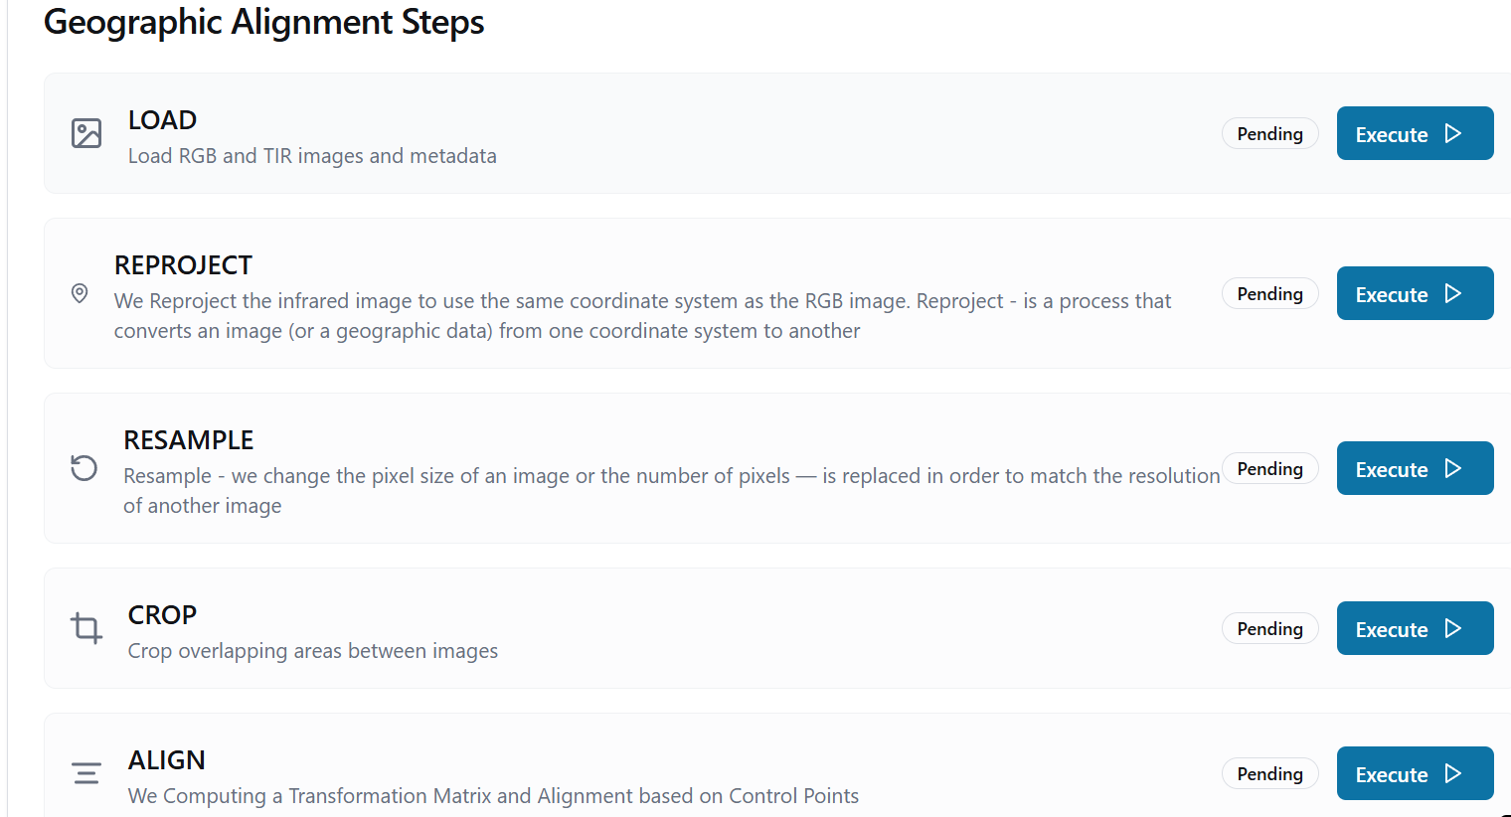.

**Step 2: Perform Semantic Segmentation Using SegFormer**

Action:Apply the SegFormer model to the RGB image to classify each pixel into land cover categories.

Explanation:SegFormer is a transformer-based semantic segmentation model. It divides the image into overlapping patches and passes them through a hierarchy of transformer blocks. Each pixel is labeled as a specific object type (e.g., building, road, vegetation, water).

Output:

A segmentation map with per-pixel class labels 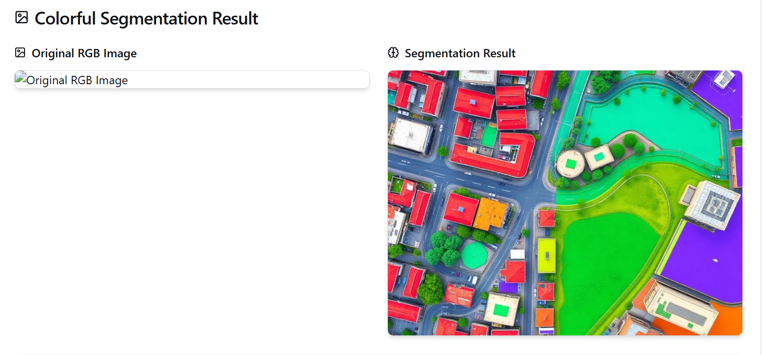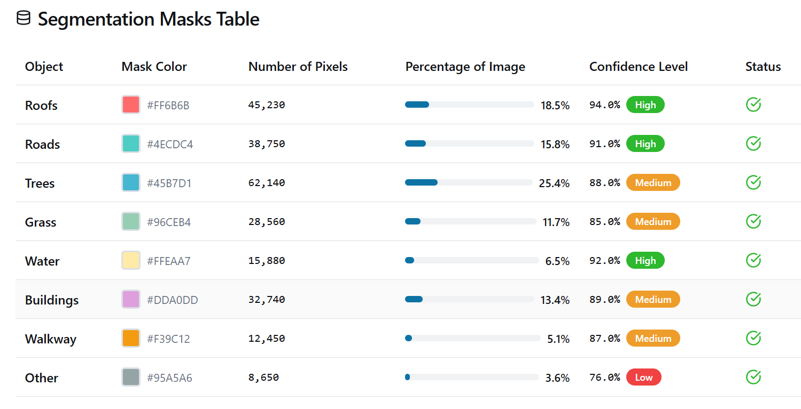.

**Step 3: Convert Thermal Image from DN to Radianc**

Action:

Use metadata from the MTL file to convert raw Digital Numbers (DN) of the TIR image into radiance values.

Explanation:

Raw thermal data from satellites like Landsat are encoded as DN values. To interpret them physically, they must be converted into Top of Atmosphere (TOA) spectral radiance using calibration coefficients from the metadata.

Output:

A radiance image in units of W/(m²·sr·µm).

**Step 4: Convert Radiance to Brightness Temperature**

Action:

Apply the Planck inverse formula using K1 and K2 constants from the metadata to convert radiance into brightness temperature.

Explanation:

This step gives the brightness temperature (the temperature a blackbody would have to emit that amount of radiation). It’s not the surface temperature yet—it still needs emissivity correction.

Output:

A brightness temperature image in Kelvin (K) 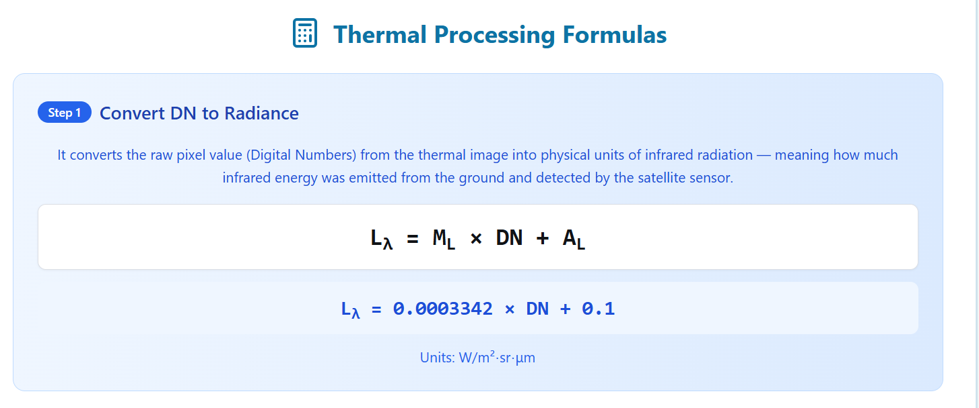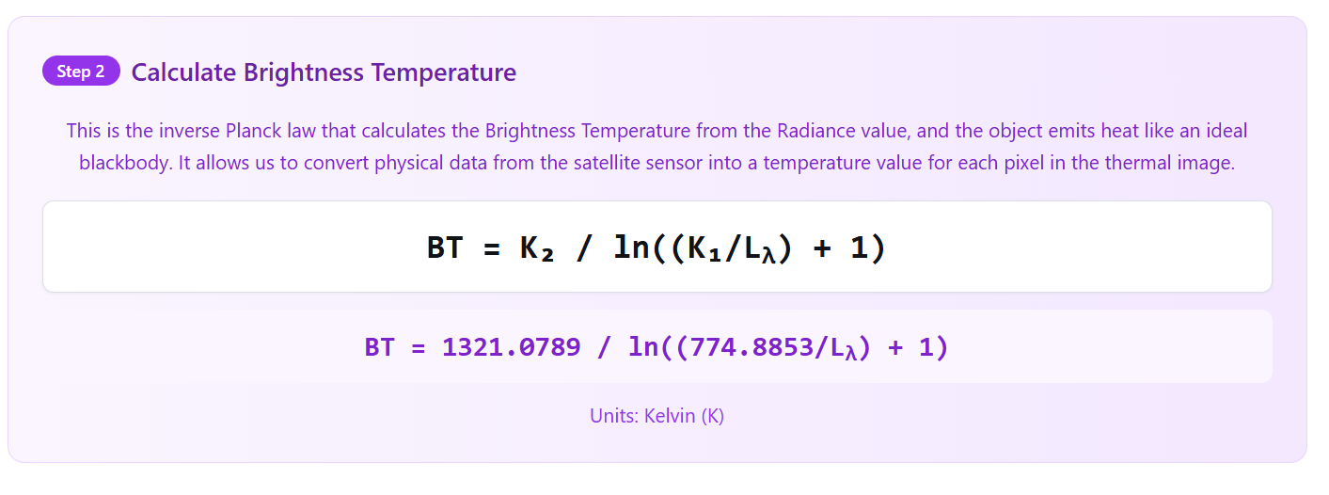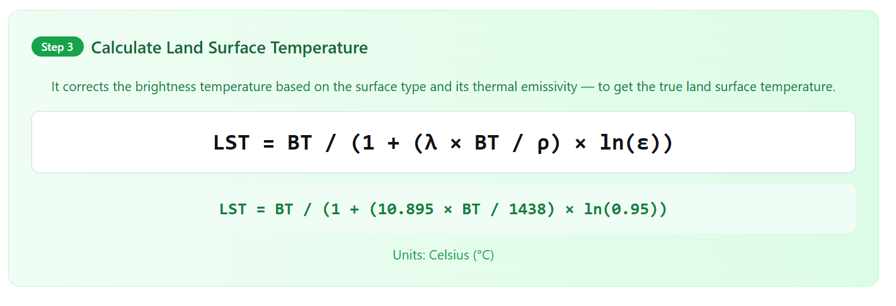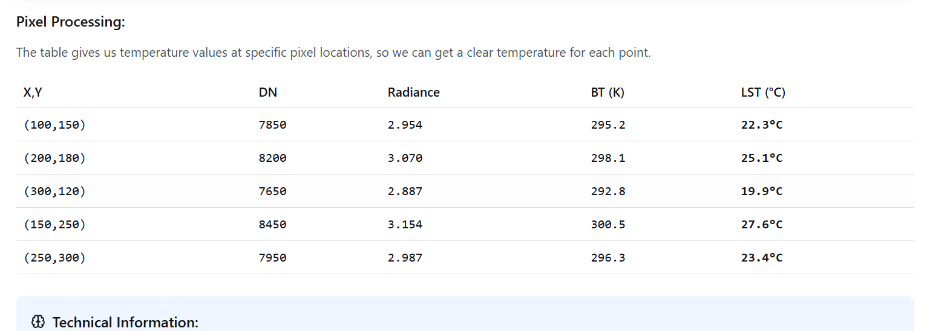.

**Step 5: Calculate Land Surface Temperature (LST)**

Explanation:

Brightness temperature needs to be corrected by emissivity to yield real surface temperature. Emissivity depends on the surface type (e.g., 0.92 for rooftops, 0.98 for vegetation).

Output:

A full-resolution LST image in °C or K, aligned with the segmentation map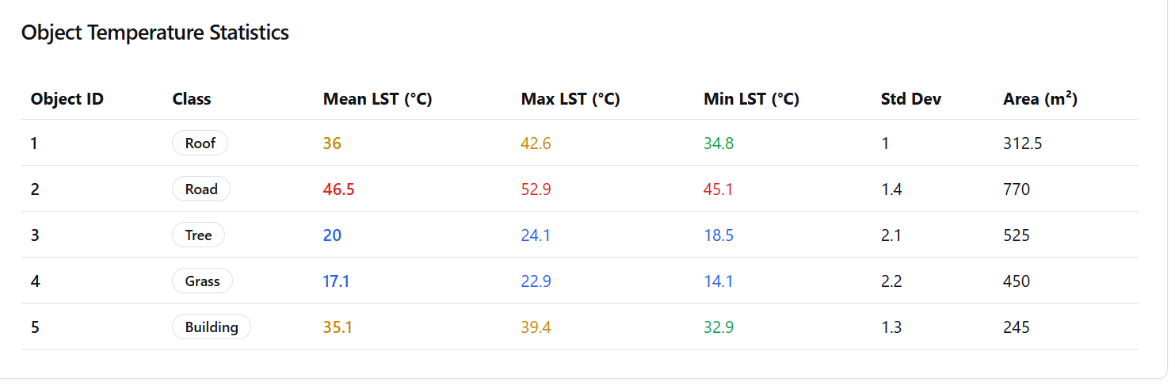.

**Step 6: Match Segmented Objects to LST Map.**

Explanation:

Now that you have object masks and temperature values, you can calculate statistics like the average surface temperature of each object type. This links geometry (shape, area) with thermal behavior.

Output:

A dictionary or table with object type → mean temperature.

**Step 7: Compute Area per Object Type**

Action:

Count the number of pixels per object and multiply by pixel resolution squared.

Explanation:

This gives the physical area in m² covered by each object type in the image, which is important for correlation analysis between area and heat.

Output:

Area per object type 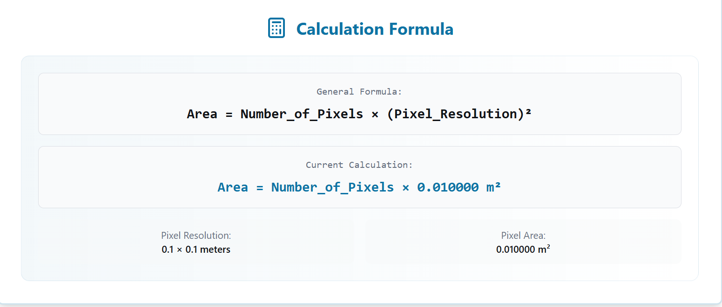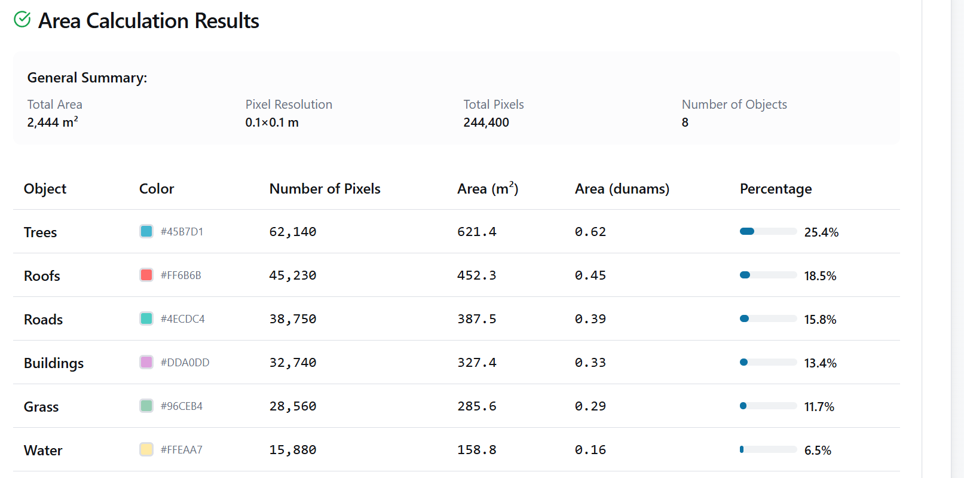

**Step 8: Create Structured Dataset**

Explanation:

This table is the core dataset for later statistical analysis. Each row corresponds to an object class with fields like object_type, area_m2, mean_LST.

Output: 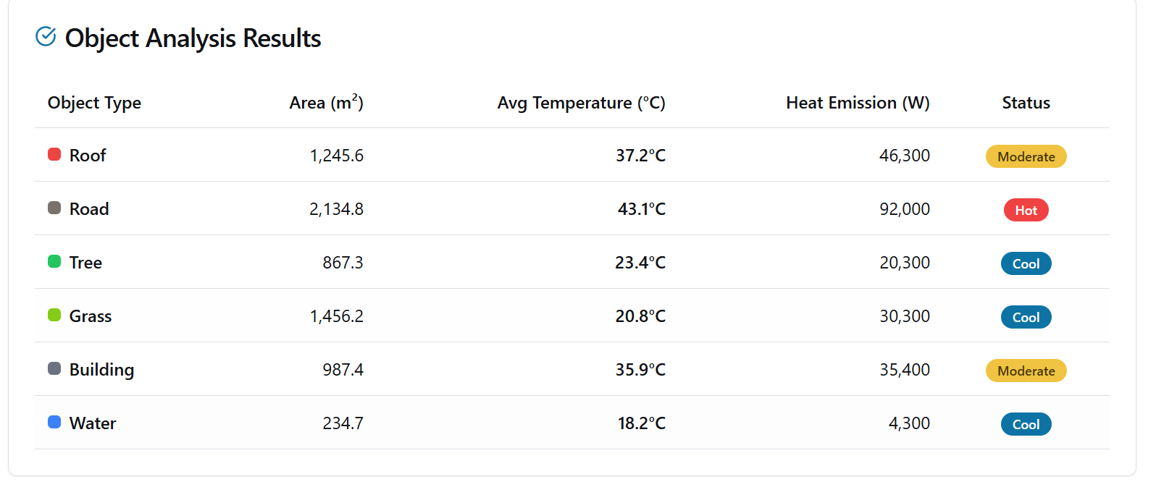

.

## Dublin 2009 and its Segmentation

|  |  |
| --- | --- |
|  |  |

## Dublin 2018 and its Segmentation

|  |  |
| --- | --- |
|  |  |

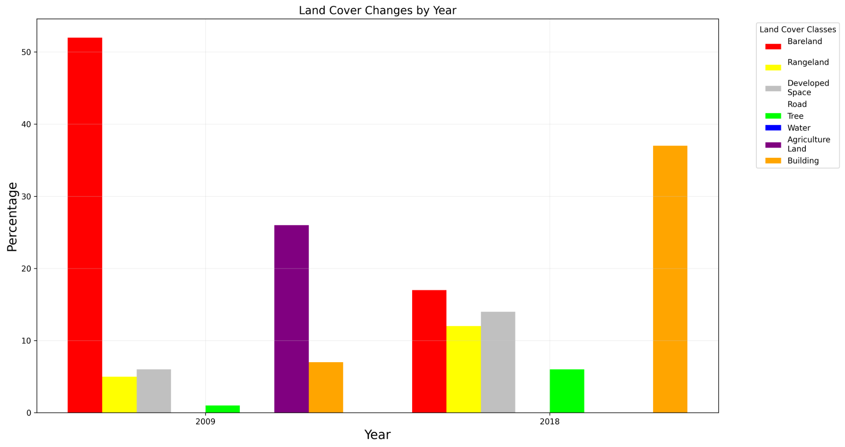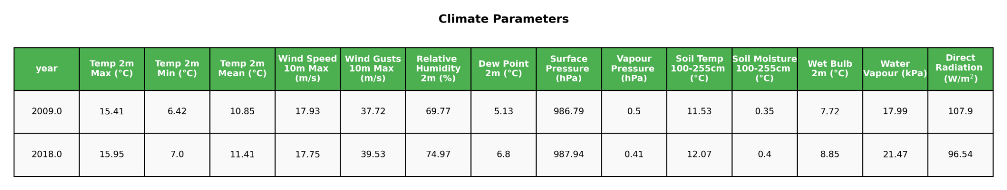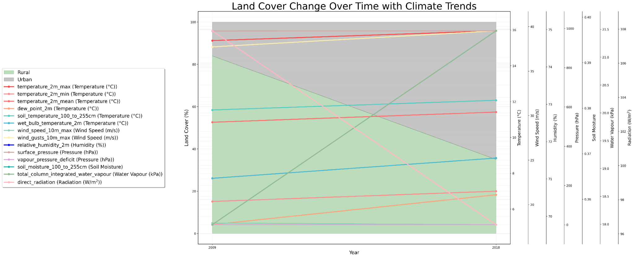

## Gilbert AZ 2013 and its Segmentation

|  |  |
| --- | --- |
|  |  |

## Gilbert AZ 2019 and its Segmentation

|  |  |
| --- | --- |
|  |  |

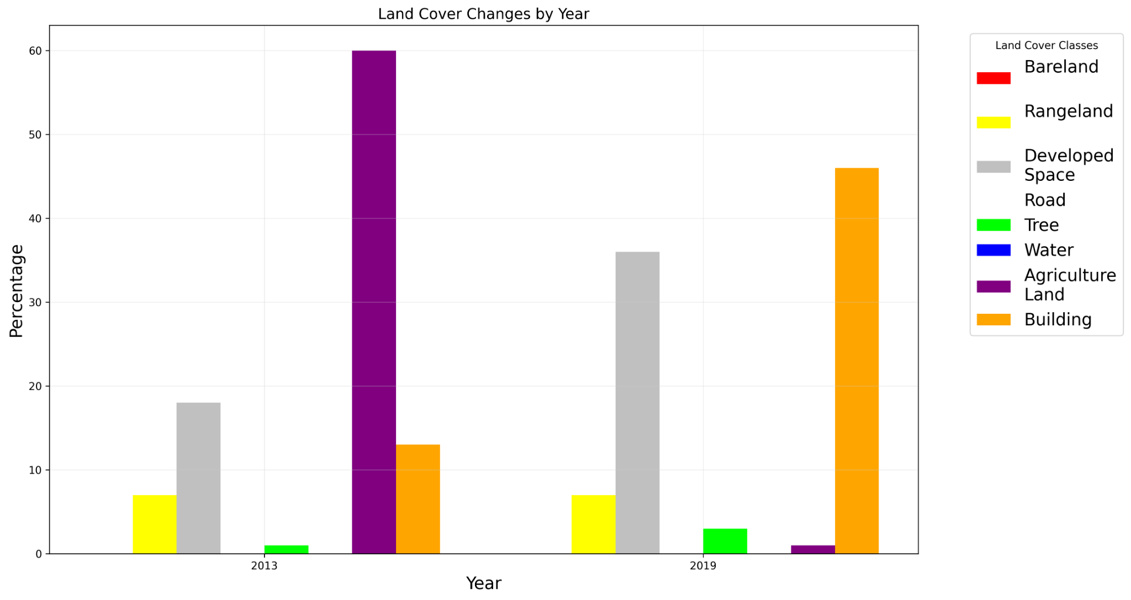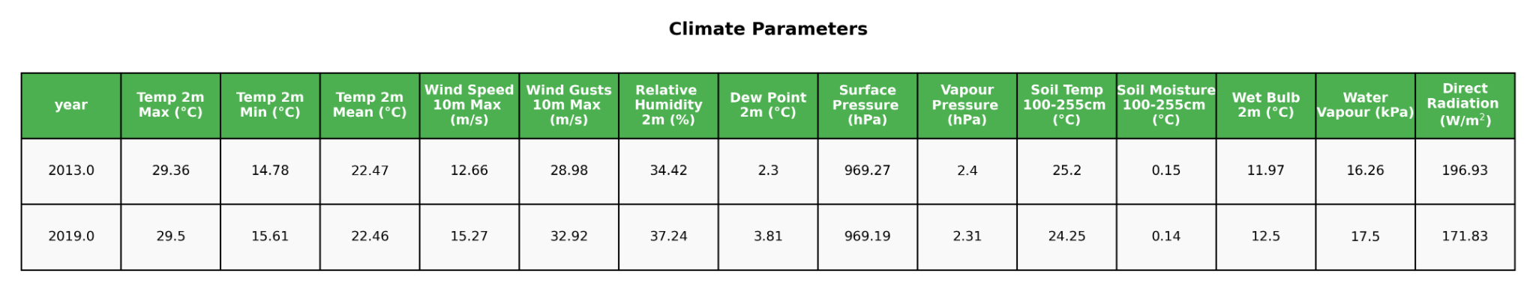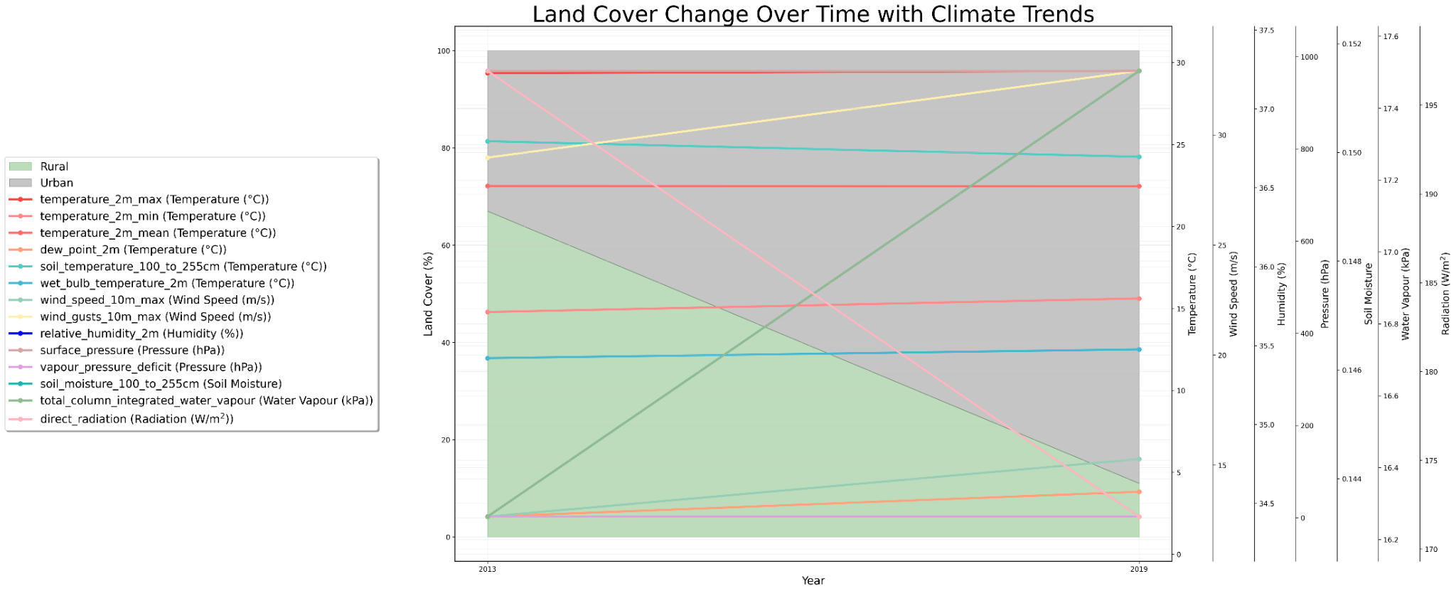

## Katy Texas 2012 and its Segmentation

|  |  |
| --- | --- |
|  |  |

## Katy Texas 2018 and its Segmentation

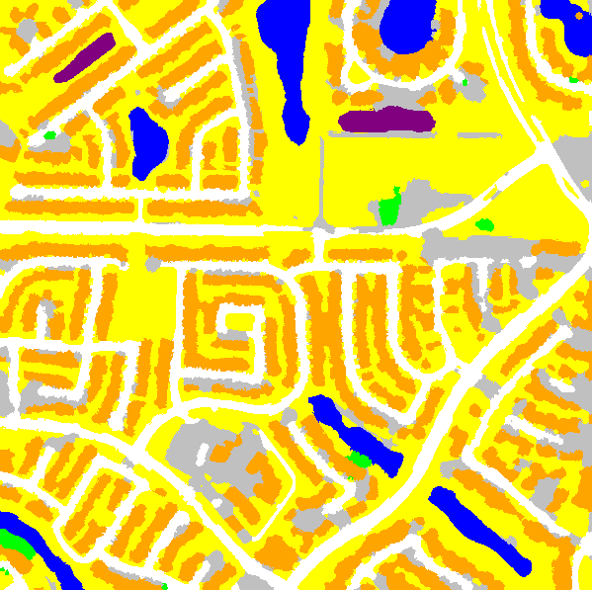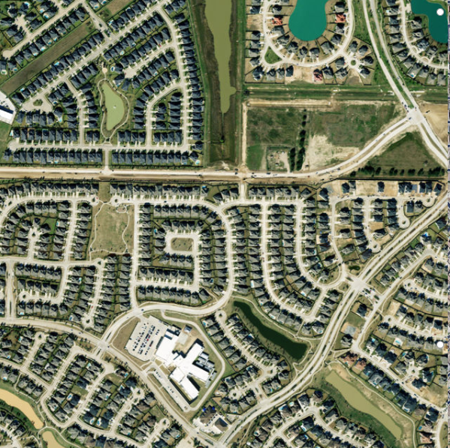

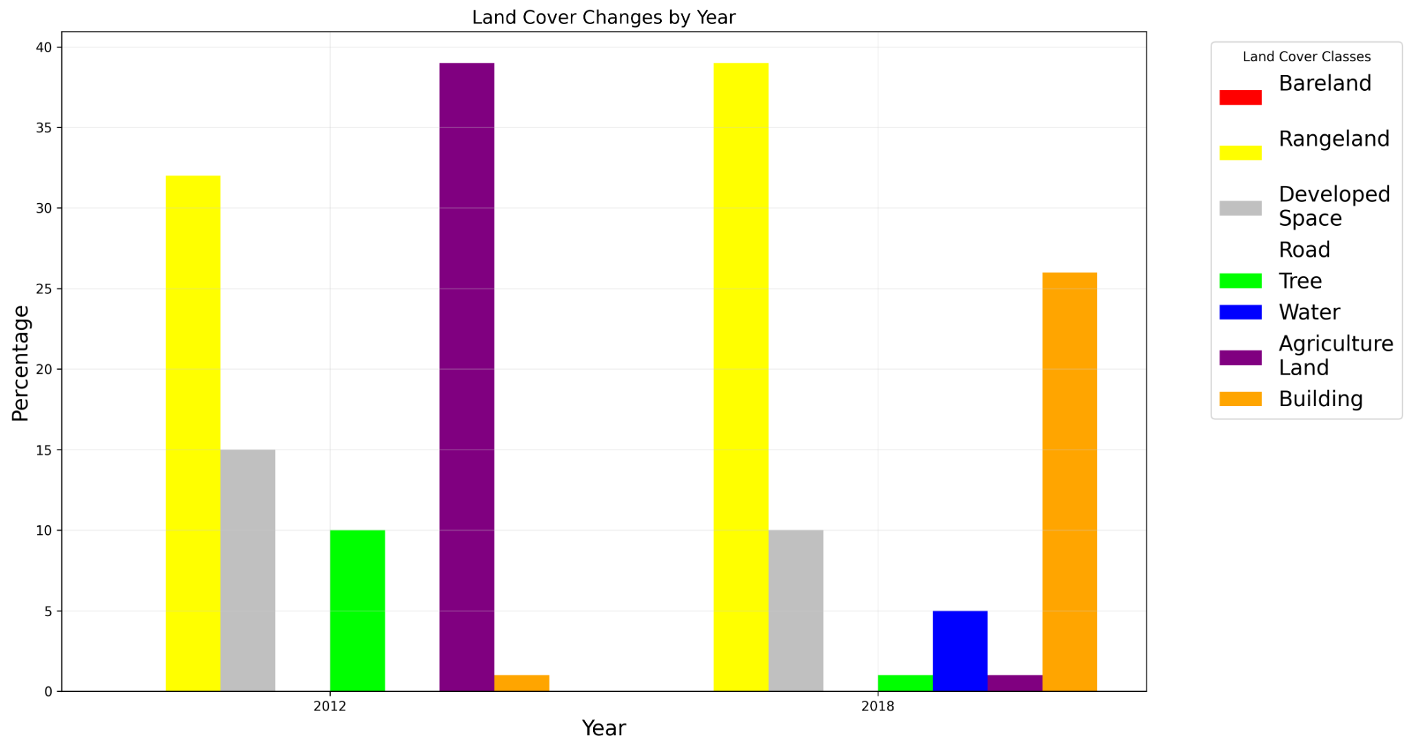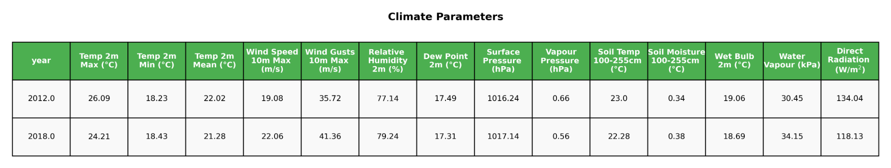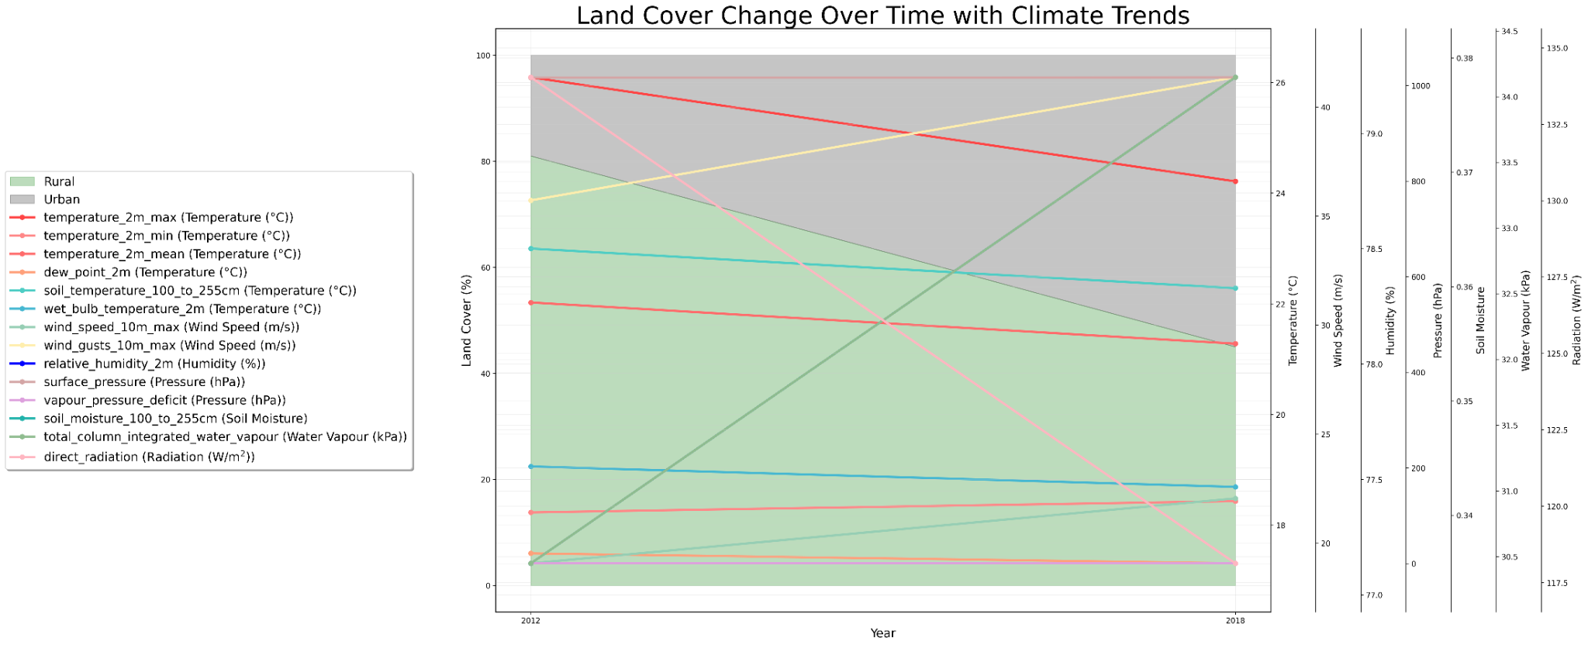

## The Villages 2007 and its Segmentation

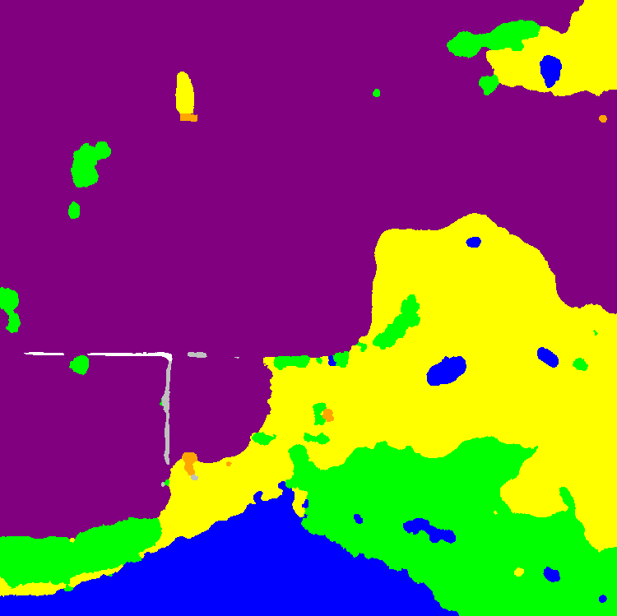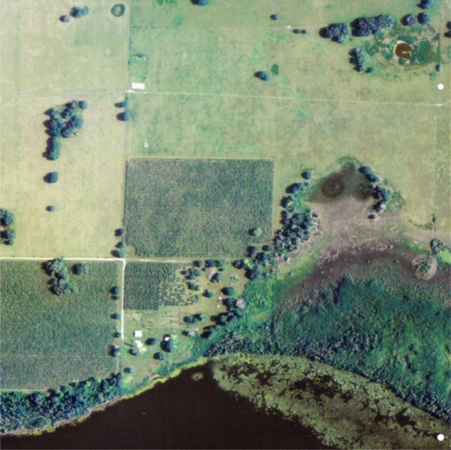  
  
The Villages 2018 and its segmentation  
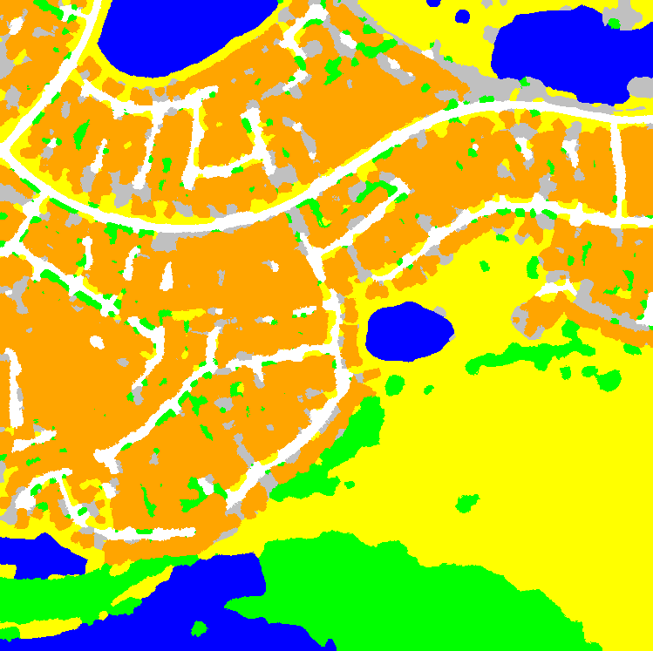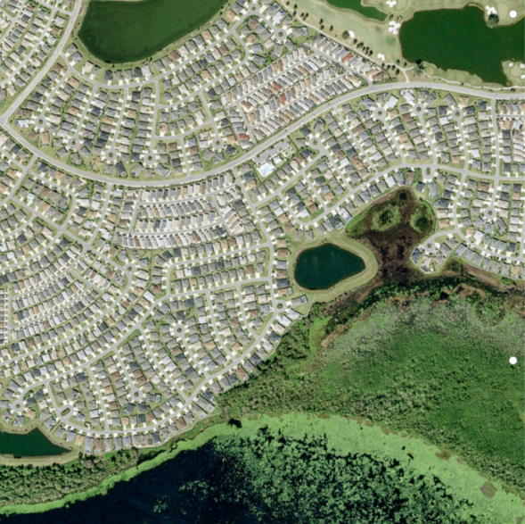

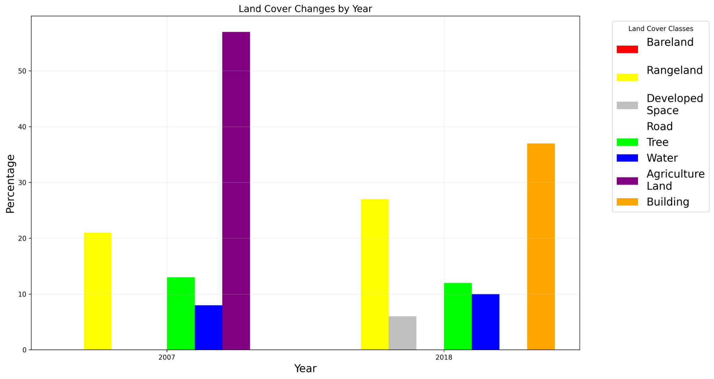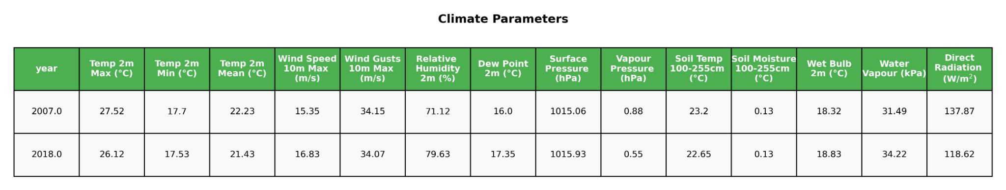

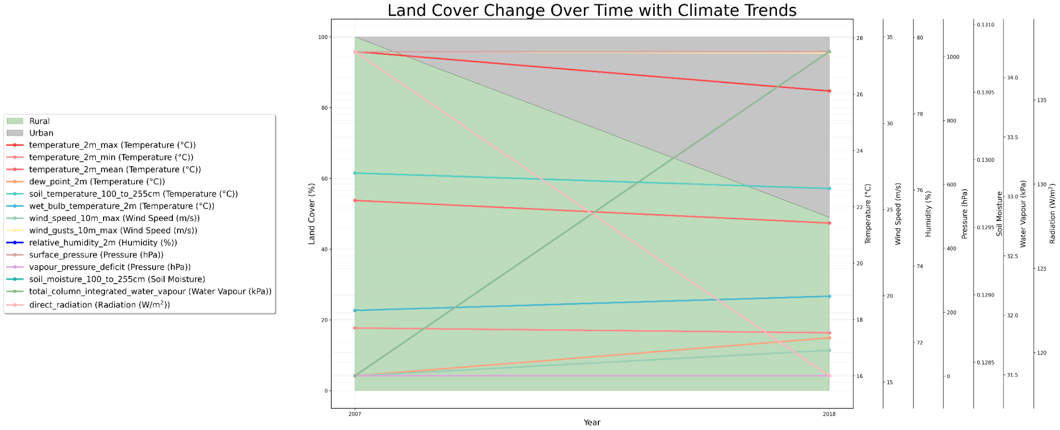

### Sources: **1. Urban Heat Island (UHI) Effect and Urban Microclimate**

* Oke, T.R. (1982). The energetic basis of the urban heat island. Quarterly Journal of the Royal Meteorological Society.
* Voogt, J.A., & Oke, T.R. (2003). Thermal remote sensing of urban climates. Remote Sensing of Environment.

### **2. Remote Sensing and Thermal Infrared Imagery**

* Weng, Q. (2009). Thermal infrared remote sensing for urban climate and environmental studies: Methods, applications, and trends. ISPRS Journal of Photogrammetry and Remote Sensing.
* USGS Landsat Missions: https://www.usgs.gov/landsat-missions
* Sentinel Hub Documentation: https://docs.sentinel-hub.com/

### **3. Land Surface Temperature (LST) Estimation (Mono-Window)**

* Qin, Z., Karnieli, A., & Berliner, P. (2001). A mono-window algorithm for retrieving land surface temperature from Landsat TM data and its application to the Israel–Egypt border region. International Journal of Remote Sensing.

### **4. Semantic Segmentation and SegFormer**

* Xie, E., Wang, W., Yu, Z., et al. (2021). SegFormer: Simple and efficient design for semantic segmentation with transformers. [arXiv:2105.15203](https://arxiv.org/abs/2105.15203)
* Hugging Face SegFormer Implementation: https://huggingface.co/docs/transformers/model_doc/segformer

### **5. Datasets Used**

* [Landsat 8/9](https://landsat.gsfc.nasa.gov/)
* Sentinel-2
* [DeepGlobe Challenge Dataset](http://deepglobe.org/)
* [WHU Building Dataset](https://github.com/whu-lambert/WHU-Building-Dataset)

### **6. AI-Based Weather Forecasting Models**

* DeepMind’s Nowcasting Project: https://www.deepmind.com/research/highlighted-research/nowcasting
* Google’s GraphCast: Pathak et al., 2022, <https://arxiv.org/abs/2212.11214>

### **7. Infrared Radiation - Physics and Detection**

* Encyclopædia Britannica – Infrared radiation: <https://www.britannica.com/science/infrared-radiation>
* NASA – Infrared light: <https://science.nasa.gov/ems/07_infraredwaves>
* IR Cameras: FLIR Systems, <https://www.flir.com/>

### **8. Infrared Satellite Instruments**

* NOAA – AIRS, IASI, CrIS Overview: https://www.nesdis.noaa.gov/
* EUMETSAT – Meteosat Info: https://www.eumetsat.int/meteosat
* NASA – GOES-R Series Overview: <https://www.goes-r.gov/>

### **9. Tools and Frameworks**

* Google Earth Engine: <https://earthengine.google.com/>
* Rasterio Documentation: <https://rasterio.readthedocs.io/en/latest/>
* NumPy: <https://numpy.org/>

### **10. Urban Planning & Heat Mitigation**

* EPA – Reducing Urban Heat Islands: <https://www.epa.gov/heatislands>
* Santamouris, M. (2014). Cooling the cities – A review of reflective and green roof mitigation technologies to fight heat island and improve comfort in urban environments. Solar Energy.